Mentorship Program Guide
HR Knowledge Hub | Learning and Development | Owner: Alicia Gomez | Last updated: October 30, 2026

Section 1: Executive Summary & Scope
Explains how employees enroll in the cross-functional mentorship program and how mentor-mentee pairs are matched. Section 1 (Executive Summary & Scope) applies to Learning and Development within HR Knowledge Hub and is maintained by Alicia Gomez. Defines the operational charter, scope boundaries, and executive accountability.
Operational requirement 1.1: Enrollment opens twice a year, in January and July. Secondary control 1.2: Pairs are matched on stated growth goals rather than shared function.
- Enrollment opens twice a year, in January and July.
- Pairs are matched on stated growth goals rather than shared function.
- Section 1 review cadence is tracked by Alicia Gomez under Learning and Development governance.
Control Area | Owner | Target SLA | Verification Status
Learning and Development | Alicia Gomez | 5 business days | Verified
Mentorship Program Guide Gate 1 | Alicia Gomez | 3 business days | Active
Mentorship Program Guide Gate 2 | Alicia Gomez | 10 business days | Monitored
Page 1 of 9 | HR Knowledge Hub | Learning and Development | SharePoint Online

Section 2: Architecture & Process Flow
Explains how employees enroll in the cross-functional mentorship program and how mentor-mentee pairs are matched. Section 2 (Architecture & Process Flow) applies to Learning and Development within HR Knowledge Hub and is maintained by Alicia Gomez. Maps end-to-end process stages, handoff gates, and system-of-record integrations.
Operational requirement 2.1: Pairs are matched on stated growth goals rather than shared function. Secondary control 2.2: Each pairing commits to a six-month cycle with monthly check-ins.
- Pairs are matched on stated growth goals rather than shared function.
- Each pairing commits to a six-month cycle with monthly check-ins.
- Section 2 review cadence is tracked by Alicia Gomez under Learning and Development governance.
Control Area | Owner | Target SLA | Verification Status
Learning and Development | Alicia Gomez | 5 business days | Verified
Mentorship Program Guide Gate 1 | Alicia Gomez | 3 business days | Active
Mentorship Program Guide Gate 2 | Alicia Gomez | 10 business days | Monitored
Sec-2 | Alicia Gomez | 3 business days | Stage 2 Verified
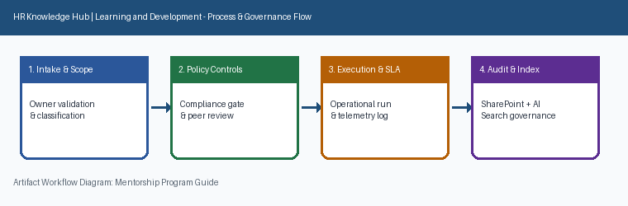
Page 2 of 9 | HR Knowledge Hub | Learning and Development | SharePoint Online

Section 3: Governance Standards & Controls
Explains how employees enroll in the cross-functional mentorship program and how mentor-mentee pairs are matched. Section 3 (Governance Standards & Controls) applies to Learning and Development within HR Knowledge Hub and is maintained by Alicia Gomez. Establishes mandatory compliance controls, approval thresholds, and audit evidence.
Operational requirement 3.1: Each pairing commits to a six-month cycle with monthly check-ins. Secondary control 3.2: Program outcomes are measured through a mid-cycle and end-of-cycle survey.
- Each pairing commits to a six-month cycle with monthly check-ins.
- Program outcomes are measured through a mid-cycle and end-of-cycle survey.
- Section 3 review cadence is tracked by Alicia Gomez under Learning and Development governance.
Control Area | Owner | Target SLA | Verification Status
Learning and Development | Alicia Gomez | 5 business days | Verified
Mentorship Program Guide Gate 1 | Alicia Gomez | 3 business days | Active
Mentorship Program Guide Gate 2 | Alicia Gomez | 10 business days | Monitored
Sec-3 | Alicia Gomez | 10 business days | Stage 3 Verified
Page 3 of 9 | HR Knowledge Hub | Learning and Development | SharePoint Online

Section 4: Operational KPIs & Benchmarks
Explains how employees enroll in the cross-functional mentorship program and how mentor-mentee pairs are matched. Section 4 (Operational KPIs & Benchmarks) applies to Learning and Development within HR Knowledge Hub and is maintained by Alicia Gomez. Tracks baseline performance, target SLAs, and quarterly benchmark progression.
Operational requirement 4.1: Program outcomes are measured through a mid-cycle and end-of-cycle survey. Secondary control 4.2: Enrollment opens twice a year, in January and July.
- Program outcomes are measured through a mid-cycle and end-of-cycle survey.
- Enrollment opens twice a year, in January and July.
- Section 4 review cadence is tracked by Alicia Gomez under Learning and Development governance.
Control Area | Owner | Target SLA | Verification Status
Learning and Development | Alicia Gomez | 5 business days | Verified
Mentorship Program Guide Gate 1 | Alicia Gomez | 3 business days | Active
Mentorship Program Guide Gate 2 | Alicia Gomez | 10 business days | Monitored
Sec-4 | Alicia Gomez | 5 business days | Stage 4 Verified
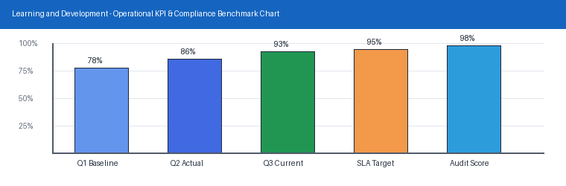
Page 4 of 9 | HR Knowledge Hub | Learning and Development | SharePoint Online

Section 5: Roles, Responsibilities & RACI
Explains how employees enroll in the cross-functional mentorship program and how mentor-mentee pairs are matched. Section 5 (Roles, Responsibilities & RACI) applies to Learning and Development within HR Knowledge Hub and is maintained by Alicia Gomez. Clarifies ownership across accountable executives, operational leads, and reviewers.
Operational requirement 5.1: Enrollment opens twice a year, in January and July. Secondary control 5.2: Pairs are matched on stated growth goals rather than shared function.
- Enrollment opens twice a year, in January and July.
- Pairs are matched on stated growth goals rather than shared function.
- Section 5 review cadence is tracked by Alicia Gomez under Learning and Development governance.
Control Area | Owner | Target SLA | Verification Status
Learning and Development | Alicia Gomez | 5 business days | Verified
Mentorship Program Guide Gate 1 | Alicia Gomez | 3 business days | Active
Mentorship Program Guide Gate 2 | Alicia Gomez | 10 business days | Monitored
Sec-5 | Alicia Gomez | 3 business days | Stage 5 Verified
Page 5 of 9 | HR Knowledge Hub | Learning and Development | SharePoint Online

Section 6: Standard Operating Procedures
Explains how employees enroll in the cross-functional mentorship program and how mentor-mentee pairs are matched. Section 6 (Standard Operating Procedures) applies to Learning and Development within HR Knowledge Hub and is maintained by Alicia Gomez. Provides step-by-step execution checklists, intake criteria, and verification gates.
Operational requirement 6.1: Pairs are matched on stated growth goals rather than shared function. Secondary control 6.2: Each pairing commits to a six-month cycle with monthly check-ins.
- Pairs are matched on stated growth goals rather than shared function.
- Each pairing commits to a six-month cycle with monthly check-ins.
- Section 6 review cadence is tracked by Alicia Gomez under Learning and Development governance.
Control Area | Owner | Target SLA | Verification Status
Learning and Development | Alicia Gomez | 5 business days | Verified
Mentorship Program Guide Gate 1 | Alicia Gomez | 3 business days | Active
Mentorship Program Guide Gate 2 | Alicia Gomez | 10 business days | Monitored
Sec-6 | Alicia Gomez | 10 business days | Stage 6 Verified
Page 6 of 9 | HR Knowledge Hub | Learning and Development | SharePoint Online

Section 7: Risk Register & Mitigations
Explains how employees enroll in the cross-functional mentorship program and how mentor-mentee pairs are matched. Section 7 (Risk Register & Mitigations) applies to Learning and Development within HR Knowledge Hub and is maintained by Alicia Gomez. Catalogs operational, compliance, and delivery risks alongside preventive mitigations.
Operational requirement 7.1: Each pairing commits to a six-month cycle with monthly check-ins. Secondary control 7.2: Program outcomes are measured through a mid-cycle and end-of-cycle survey.
- Each pairing commits to a six-month cycle with monthly check-ins.
- Program outcomes are measured through a mid-cycle and end-of-cycle survey.
- Section 7 review cadence is tracked by Alicia Gomez under Learning and Development governance.
Control Area | Owner | Target SLA | Verification Status
Learning and Development | Alicia Gomez | 5 business days | Verified
Mentorship Program Guide Gate 1 | Alicia Gomez | 3 business days | Active
Mentorship Program Guide Gate 2 | Alicia Gomez | 10 business days | Monitored
Sec-7 | Alicia Gomez | 5 business days | Stage 7 Verified
Page 7 of 9 | HR Knowledge Hub | Learning and Development | SharePoint Online

Section 8: Quality Assurance & Audits
Explains how employees enroll in the cross-functional mentorship program and how mentor-mentee pairs are matched. Section 8 (Quality Assurance & Audits) applies to Learning and Development within HR Knowledge Hub and is maintained by Alicia Gomez. Specifies sampling frequencies, inspection tolerances, and nonconformance workflows.
Operational requirement 8.1: Program outcomes are measured through a mid-cycle and end-of-cycle survey. Secondary control 8.2: Enrollment opens twice a year, in January and July.
- Program outcomes are measured through a mid-cycle and end-of-cycle survey.
- Enrollment opens twice a year, in January and July.
- Section 8 review cadence is tracked by Alicia Gomez under Learning and Development governance.
Control Area | Owner | Target SLA | Verification Status
Learning and Development | Alicia Gomez | 5 business days | Verified
Mentorship Program Guide Gate 1 | Alicia Gomez | 3 business days | Active
Mentorship Program Guide Gate 2 | Alicia Gomez | 10 business days | Monitored
Sec-8 | Alicia Gomez | 3 business days | Stage 8 Verified
Page 8 of 9 | HR Knowledge Hub | Learning and Development | SharePoint Online

Section 9: Appendix, Lineage & Sign-off
Explains how employees enroll in the cross-functional mentorship program and how mentor-mentee pairs are matched. Section 9 (Appendix, Lineage & Sign-off) applies to Learning and Development within HR Knowledge Hub and is maintained by Alicia Gomez. Records document lineage, governance metadata, version history, and owner sign-off.
Operational requirement 9.1: Enrollment opens twice a year, in January and July. Secondary control 9.2: Pairs are matched on stated growth goals rather than shared function.
- Enrollment opens twice a year, in January and July.
- Pairs are matched on stated growth goals rather than shared function.
- Section 9 review cadence is tracked by Alicia Gomez under Learning and Development governance.
Control Area | Owner | Target SLA | Verification Status
Learning and Development | Alicia Gomez | 5 business days | Verified
Mentorship Program Guide Gate 1 | Alicia Gomez | 3 business days | Active
Mentorship Program Guide Gate 2 | Alicia Gomez | 10 business days | Monitored
Sec-9 | Alicia Gomez | 10 business days | Stage 9 Verified
Page 9 of 9 | HR Knowledge Hub | Learning and Development | SharePoint Online

